Mental health and wellbeing
Staying at home and the change of routine may make this a difficult time for some children and they may be feeling a range of emotions about it.
They might get upset more often, or return to some behaviours they had grown out of. It’s understandable and other families will be experiencing this.
Way to help children understand their feelings:
Talk to your child about coronavirus

There are stories like this one and online resources that can help you with this.

Talk to your child about things that interest them

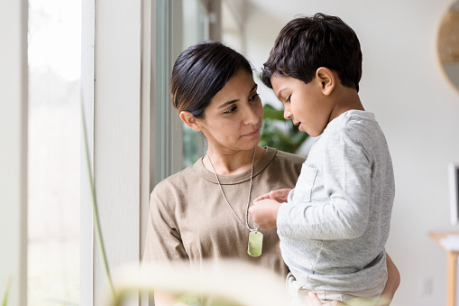

Read lots of books and stories together

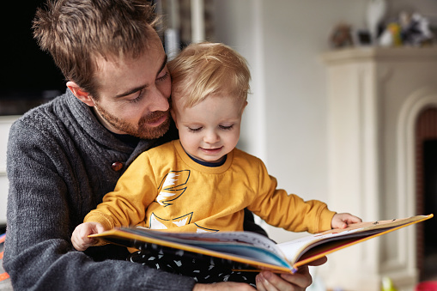

Play together

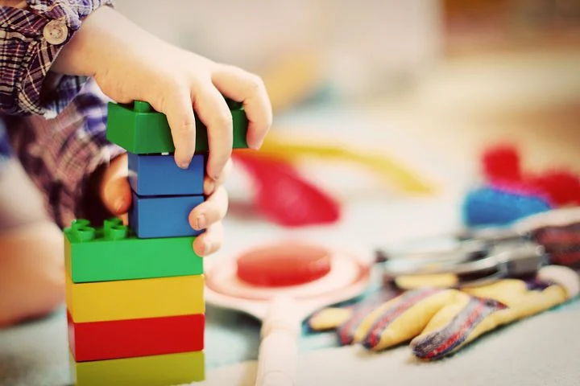

Learn a new rhyme or song

