Local support for Liverpool families
Liverpool Early Help Directory
https://ehd.liverpool.gov.uk/kb5/liverpool/fsd/family.page?familychannel=0
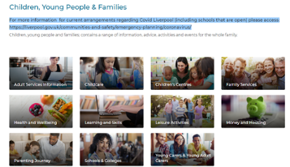
Liverpool Library Services
https://liverpool.gov.uk/libraries/find-a-library/central-library/
Liverpool Learning Partnership
https://www.liverpoollearningpartnership.com/resources-to-help-during-social-distancing-and-self-isolation/
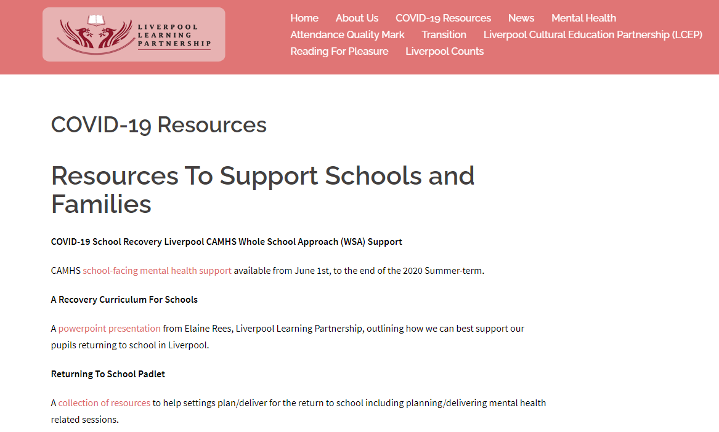
School Improvement Liverpool Early Years Resource Padlet
https://en-gb.padlet.com/sammckenna/lonbutmfe8uwx0dz
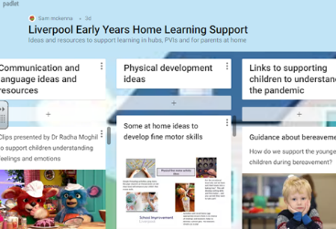

Liverpool Parents and Carers (LivPaC)
https://livpac.org.uk/
