Online support for families of children with SEND

BBC Bitesize
https://www.bbc.co.uk/bitesize/articles/zh9v382
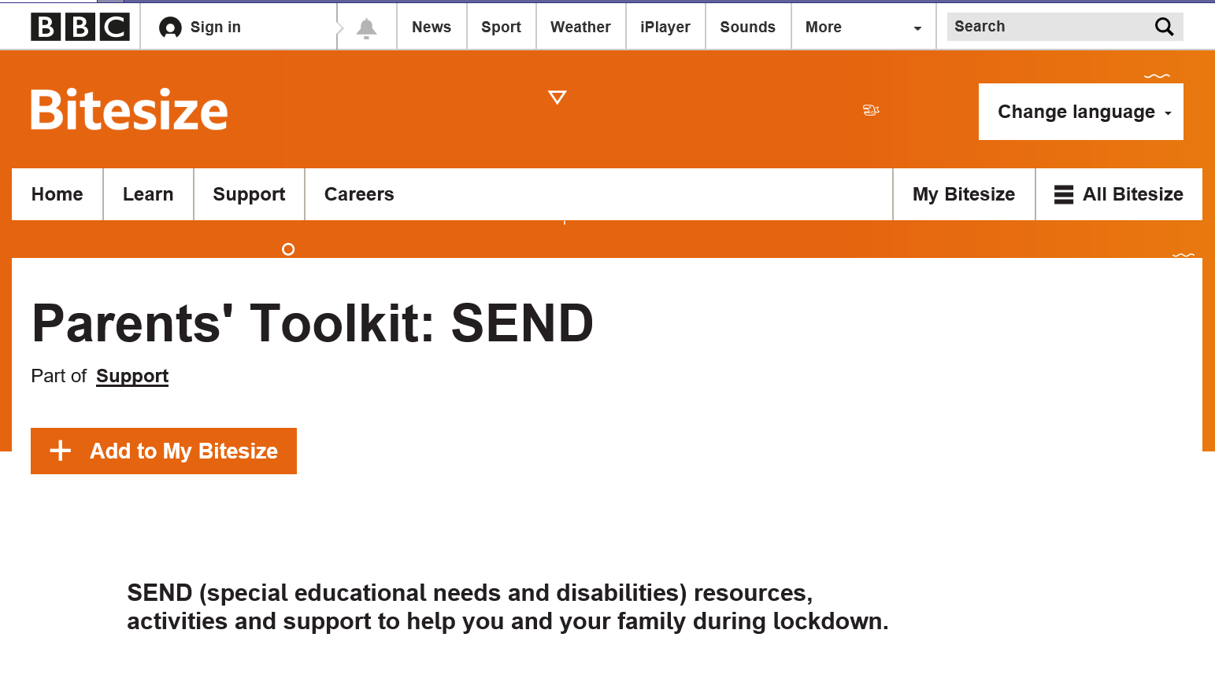
UCL home schooling advice
https://www.ucl.ac.uk/ioe/departments-and-centres/centres/centre-inclusive-education/homeschooling-children-send/early-years
Disabled Children Partnership
https://disabledchildrenspartnership.org.uk/coronavirus/
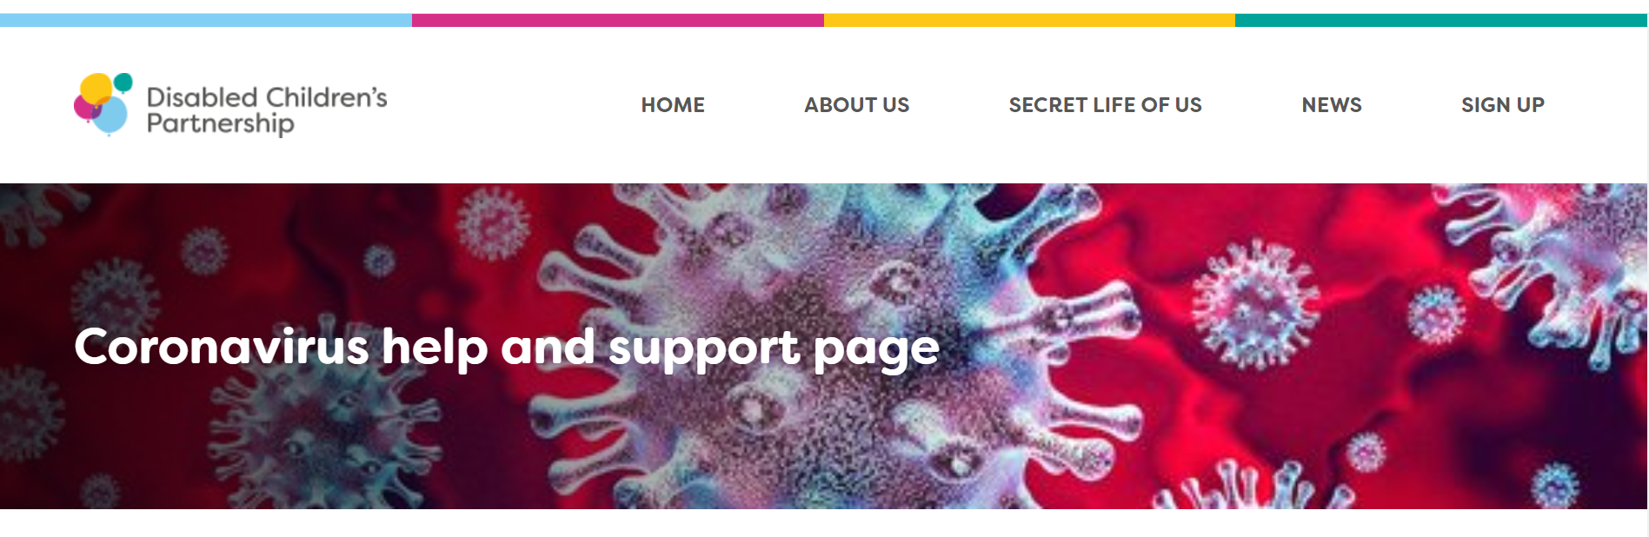
The Isabella Trust
https://www.theisabellatrust.org/information-and-resources/

Portage
https://www.portage.org.uk/support/resources/parent-list/317
The ADHD Foundation
https://www.adhdfoundation.org.uk/
Barnados
https://www.barnardos.org.uk/support-hub/send

