Guidance videos for parents/carers
Looking for more information about ways to support your child’s development? Click the links to watch our short video guides for parents/carers of 0 to 4 year olds.

Guide 1: Preparing for Phonics; Supporting your child in the early years
https://zoom.us/rec/share/ezGCHLUByYVQ-LWdPUl9Lf6_D34oBTRIwQ-EDbgEPzQeE5dYgAmbkrpdglnikAGu.OpUqM83WDg6_6MNb

Guide 2: Supporting your child with their reading in the early years
https://zoom.us/rec/share/qOBihXc-gPGcw27P-H0awEFW9_MZ93cKLBupxWFFpgTEErD46V33xz0HNmw1oh0e.7ngL_LyTcLT6-yDd

Guide 3: Supporting your child with their communication and language development in the early years
https://zoom.us/rec/share/cE7iq4WuK01lBt3us55nF3FMbR5JdtZ6zTa2dyO8RYYAx86AOE5snrzc05pKa0_g.lQQ_7Z9KQM4oRynu

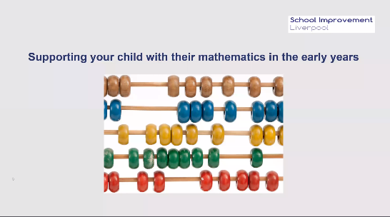
Guide 4: Supporting your child with their mathematics in the early years
https://zoom.us/rec/share/e0uR38CI4aQuGn1LzWU1uHm0U91tMuQ5C5QqDBrMZ0SHughn5DUpa47-WRYtLK-q.SUArtHX94Qf1BIaV

